|  |
| --- |
| KIET Group of Institutions, Ghaziabad  *CS Department*      Internship Report  On  Internet Speed Test  Using python.      Summer Internship at KIET Group of Institution  Mini Project    (Duration)  (2022)    Submitted By :  Abhishek Rajput  B.TECH/CS  (Sem.3-Sec.A)  2100290120007 |

INDEX

1. Acknowledgement
2. Certificate
3. Abstract
4. Introduction
5. Details of Task
6. Conclusion
7. Future Scope
8. Research paper
9. MOOC certificate

ACKNOWLEDGEMENT

I’ve got this golden opportunity to express my kind gratitude and sincere thanks to my Head of Institution, KIET Group of Institutions of Engineering and Technology, and Head of Department of CS for their kind support and necessary counselling in the preparation of this project report. I’m also indebted to each and every person responsible for the making up of this project directly or indirectly.

I must also acknowledge or deep debt of gratitude each one of my college who led this project come out in the way it is. It’s my hard work and untiring sincere efforts and mutual cooperation to bring out the project work. Last but not the least, I would like to thank my parents for their sound counselling and cheerful support. They have always inspired us and kept our spirit up.

ABHISHEK RAJPUT

B.TECH-CS

SEMESTER-3

2100290120007

CERTIFICATE

This is to certify that the internship project report entitled Internet Speed test system submitted by ABHISHEK RAJPUT in the Department of CS of KIET Group of Institutions, Ghaziabad, affiliated to Dr. A. P. J. Abdul Kalam Technical University, Lucknow, Uttar Pradesh, India, is a record of candidate summer internship. He has successfully completed his internship under my supervision and guidance and is worthy of consideration for the same.

Signature of Supervisor:

Supervisor’s Name:

Date:

Internet Speed Test system :

Abstract: You must have checked the speed of your internet connection once in your life using platforms like [speedtest.net](https://www.speedtest.net/). Have you ever thought about doing the same with Python? Well if you want to learn how to perform an internet speed test using Python then this article is for you. In this article, I will present a tutorial on how to perform an internet speed test using Python.

Introduction : When checking the speed of the Internet connection, the results are displayed as download speed and upload speed. **Download speed refers to the speed at which your internet connection downloads data from the internet and upload speed refers to the speed at which your internet connection uploads data to the internet.** So, calculating the download speed and the upload speed of an Internet connection sums up the Internet speed test.

Details of task :

from tkinter import *

from typing import Any

from click import command;

import speedtest

def speedcheck():

sp = speedtest.Speedtest()

sp.get_servers()

down = str(round(sp.download()/(10**6),3)) + " Mbps"

up= str(round(sp.upload()/(10**6),3)) + " Mbps"

lap_down.config(text=down)

lap_up.config(text=up)

sp =Tk()

sp.title("Internet Speed Test")

sp.geometry("500x600")

sp.config(bg="White")

lab = Label(sp,text ="Internet Speed Test" , font=("Time New Roman", 20, "bold"))

lab.place(x=60,y=40,width=380)

lab = Label(sp,text ="Downloading Speed" , font=("Time New Roman", 20, "bold"))

lab.place(x=60,y=130,width=380)

lab_down= Label(sp,text ="00" , font=("Time New Roman", 20, "bold"))

lab_down.place(x=60,y=200,width=380)

lab = Label(sp,text ="Upload Speed" , font=("Time New Roman", 20, "bold"))

lab.place(x=60,y=290,width=380)

lab_up = Label(sp,text ="00" , font=("Time New Roman", 20, "bold"))

lab_up.place(x=60,y=360,width=380)

button = Button(sp,text="Check Speed", font=("Time New Roman", 20, "bold"),relief=RAISED ,bg="Green",command=speedcheck)

button.place(x=60,y=460,width=380)

sp.mainloop()

Output:

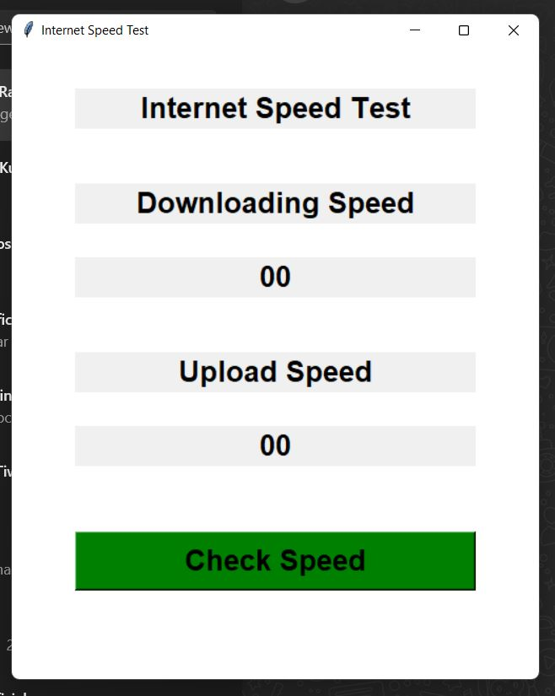

### Summary of Internship:

Calculating the download speed and the upload speed of an Internet connection sums up the Internet speed test. Download speed refers to the speed at which your internet connection downloads data from the internet and upload speed refers to the speed at which your internet connection uploads data to the internet. I hope you liked this article on how to calculate the speed of your internet connection using Python.

Conclusion :

In this article we discussed how to test internet speed using Python as well as covered the features of the speetest-cli library and showed how some parameters can be adjusted.

Feel free to leave comments below if you have any questions or have suggestions for some edits and check out more of my [Python Programming](https://pyshark.com/category/python-programming/) articles.

**MOOC CERTIFICATE**



Verification Link :- <https://www.udemy.com/certificate/UC-d94ad93e-97e1-44fb-8be4-581f7cb5f984/>

Certificate of Internship

